FOREIGN TRADE UNIVERSITY
VIETNAM-JAPAN SCHOOL OF BUSINESS AND INNOVATION

==***==


EXECUTIVE SUMMARY
ADVANCED BUSINESS ANALYTICS

HOTEL BOOKING CANCELLATION DECISION SUPPORT
CITY HOTEL LISBON

Group: 2
Class: DBZ405E(DB-HK1-2627)K62.1
Lecturer: GS. Hồ Tú Bảo, PGS.TS. Trần Thị Oanh

Ha Noi, 2026

MEMBER CONTRIBUTION
NAME | STUDENT ID | TASKS | %
Vũ Minh Trang | 2313560046
Vũ Minh Thư | 2312560044
Phạm Lương Duyên | 2313560009
Trần Ngọc Thành | 2312560042
Nguyễn Thị Minh Thư | 2311560045
Lý Vân Ngọc | 2314560032
Hoàng Thị Thùy Dương
Nguyễn Quốc Tuấn

Introduction
City Hotel Lisbon loses sight of 41.7% of its bookings to cancellation or no-show. We propose a decision-support system that scores each booking for risk every week, routes the riskiest and most valuable bookings to staff within their capacity, and measures whether acting on them pays off. On a simulation of the 2017 weekly queue the proposed policy returns about EUR 30.4k a year net once fully rolled out, with a 3-year ROI of 173% and payback in 6.9 months from roll-out, subject to a randomised pilot.
PDMT stage | Key message
Problem | 33,102 of 79,330 bookings (Jul 2015 – Aug 2017) did not arrive, tying up EUR 10.9M of EUR 25.3M gross booked room revenue. Risk varies sharply by segment, yet follow-up is not risk-based.
Data | One real PMS extract (79,330 bookings) plus labelled synthetic tables for cost, commission, inventory, resale and guest contact, joined on booking_id in a PostgreSQL schema.
Method | (1) An XGBoost risk model, validated in time order, ranks bookings better than simple rules (AUC 0.736 vs 0.678). (2) Capacity-limited decision rules turn scores into calls, reminders and group actions, valued on a contribution basis.
Tools | Python for scoring and rules, PostgreSQL/SQLite for data and an approval-guarded action store, Streamlit dashboard for staff, n8n for automation. Built and tested as a retrospective prototype.
What we ask management to approve: a 12-month randomised pilot of the call and reminder policy, with CX guardrails, to confirm the effect before scaling.

PDMT Map
The map links the problem to the data, the two methods and the tools summarised in Sections 1–4, and to the expected value in Section 5.
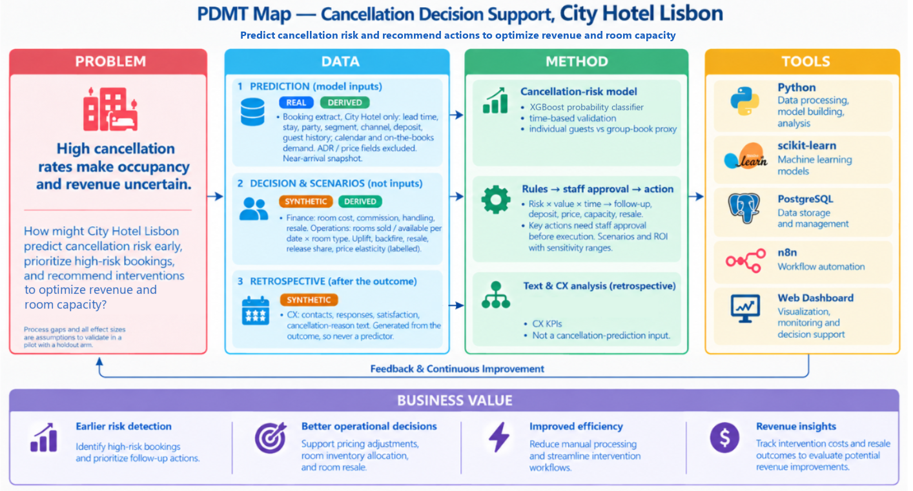

1. Problem
Cancellation is a strategic revenue-risk problem for City Hotel Lisbon, not just an operational event: revenue stays uncertain until the guest arrives, and blanket responses such as rigid policies or overbooking can harm revenue and reputation (Antonio et al., 2017).
Pain points:
- Limited visibility of risk. 41.7% of bookings (33,102) were cancelled or no-show. Most cancellations come weeks ahead (median 58 days), which leaves time to act if risk is known early; 12.0% come within 7 days, when resale is hardest.
- Follow-up not targeted. Travel agents and operators handle 87% of bookings. Cancellation rates range from 17.3% (Direct) to 37.4% (Online TA) and 68.9% (Groups), yet at-risk guests are not systematically contacted (assumed current practice).
- Revenue and capacity not optimised. EUR 10.9M of EUR 25.3M gross booked room revenue (43%) sits in bookings that were cancelled. This is exposure, not realised loss, and commission, handling cost and resale are not linked to risk.
Stakeholders: The General Manager and Revenue Manager decide; Reservations, CX and Distribution act; Finance judges net value; the Data team owns the model; guests are affected but are not system users.
Decisions to improve and objectives
Decision | Business question | Supported by | Objective
Risk identification | Which bookings are likely to cancel? | Machine learning | Identify risk at booking time, while there is time to act
Resource prioritisation | Which bookings should staff handle first? | Risk score × booking value | Focus effort on the highest-risk, highest-value bookings
Intervention selection | Confirm, remind or call? | Business rules | Match action intensity to risk and value
Revenue and capacity | Which actions raise revenue and occupancy at a justified cost? | Rules + ROI analysis | Optimise revenue net of cost; test pricing as a scenario
Problem Statement: How might City Hotel Lisbon predict cancellation risk early, prioritise high-risk bookings, and recommend proportionate interventions to optimise revenue and room capacity?

2. Data
The data combine one real PMS extract with simulated tables that fill its gaps, and every field is labelled REAL, DERIVED, SYNTHETIC or SYSTEM so simulated figures are never presented as facts.
Sources
Source | Content | Grain | Use
PMS extract (Antonio et al., 2019) | 79,330 City Hotel bookings, arrivals Jul 2015 – Aug 2017; timing, stay, party, segment, channel, deposit, agent, guest history, outcome | Booking | Model features and target
Synthetic CX | Contact, channel, response, satisfaction, cancellation reason | Booking | Workflow design only
Synthetic Finance | Room cost (27% of ADR), commission (Online TA 18%, Offline 20%, Groups 10%), handling cost, resale revenue | Booking | Value at risk and scenarios
Synthetic Operations | Available rooms (252), rooms sold, rooms resold | Date × room type | Capacity and resale
Assumptions sit in one register, sourced for Lisbon or Portugal 2015–2017 where possible, each with a sensitivity range. Synthetic tables feed value and scenarios, never the classifier.

Architecture: All tables join on booking_id; inventory joins through the nights each booking covers. The PostgreSQL schema (10 tables, 2 views) enforces keys and CHECK constraints and passes 30 of 30 load checks; all 100 fields are documented.
Preparation and quality:
- All 79,330 rows are kept and problems flagged; only 438 impossible rows (0.55%) are excluded, leaving 78,892 for modelling.
- 25,902 exact duplicates (mostly group blocks) are kept and flagged; results are reported with and without them.
- Bookings are split into two populations: individual (52,676; cancel rate 28.0% → 34.4% from 2015–16 to 2017) and group/block (26,216; Groups, Non Refund or 5+ identical bookings; 64.2% → 66.7%).
- Data are split by arrival date: three rolling folds in 2016 for selection, final fit to 31 Dec 2016, test on Jan–Aug 2017.
Leakage and drift controls: Fields unknown at scoring time (reservation status, booking changes, assigned room, country, ADR) are excluded. New agents (PSI 1.09) and a 16.5% rise in median ADR in 2017 are handled by rebuilding the top-15 agent list inside each fold and leaving price out of the model.
Integration and ethics: Different system IDs are mapped to booking_id; scores and actions are time-stamped. Under the GDPR the design minimises personal data, requires human review for deposits and relocations, excludes “country” for fairness, and labels every simulated figure.

3. Methods
Two methods work in sequence: Method 1 estimates who is likely to cancel, and Method 2 decides what to do about it and whether it pays.

3.1 Method 1: Cancellation risk prediction (machine learning)
- Scope: Individual bookings only; group blocks follow a separate rule. Target: cancelled or no-show.
- Design: Booking-time features → three time-ordered 2016 folds → logistic regression and XGBoost tuned on log-loss → final fit to 31 Dec 2016 → one test on Jan–Aug 2017 → weekly scoring of bookings still active at the end of their booking week.
- Models Rationale: Gradient boosting and logistic regression are the families most often used in hotel-cancellation research (e.g., Yoo et al., 2024; Alkan, 2025). XGBoost captures interactions such as agent × lead time; logistic regression is the transparent benchmark. XGBoost won on log-loss (0.551 vs 0.558).
2017 test, individual bookings (20,399; 34.4% cancelled) | AUC | PR-AUC | Precision@20% | Lift@20%
XGBoost | 0.736 | 0.556 | 58.3% | 1.70
Rule: segment × lead time | 0.678 | 0.468 | 50.8% | 1.48
Random | 0.500 | 0.344 | 34.4% | 1.00
- The top 20% catches 308 more cancellations than the rule; the top risk decile cancels 60.7%, 8.5 times the lowest.
- Ranking by risk × value puts 52% of cancelled revenue in the top 20% of bookings (random: 20%).
- Main drivers: travel agent, lead time, customer type and length of stay (associations, not causes).

Evaluation plan
KPI | Target | 2017 result
Recall@20% | ≥ rule | 33.9% vs 29.5%
Precision@20% / Lift@20% | ≥ 50% / ≥ 1.5 | 58.3% / 1.70
PR-AUC, Brier | better than baseline LR | 0.556, 0.192 vs 0.493, 0.209
Revenue captured@20% | ≥ 50% (expected loss) | 52.2%

3.2 Method 2: Risk-based decision rules and business value
- Tiering: Each weekly batch: the top 15% by risk × booking value get a call; the next bookings up to 60% get personalised reminders; the rest get standard confirmation. Shares were chosen from 42 candidate policies on 2016 data and frozen before 2017.
- Routing: Calls (I3) within 7 days of decision, at least 8 days before arrival, max 20 a day; reminders (I2) at 30 and 14 days (one at once if a milestone has passed); no contact within 7 days (I5, counted in a capacity buffer). Group blocks get capacity reallocation and resale (G2) and price changes (G5) with Revenue Manager approval; confirm/release asks to agents (G1) are valued in scenario S5 but not yet built. Overbooking (G3) is disabled.
- Valuation: Contribution basis (revenue net of commission and room cost). Benefit = prevented cancellations × their value minus what resale would recover; reminder backfire is subtracted. Costs: EUR 1.41 per call task, EUR 0.05 per SMS, EUR 15,564 one-off and EUR 3,360 a year to run.
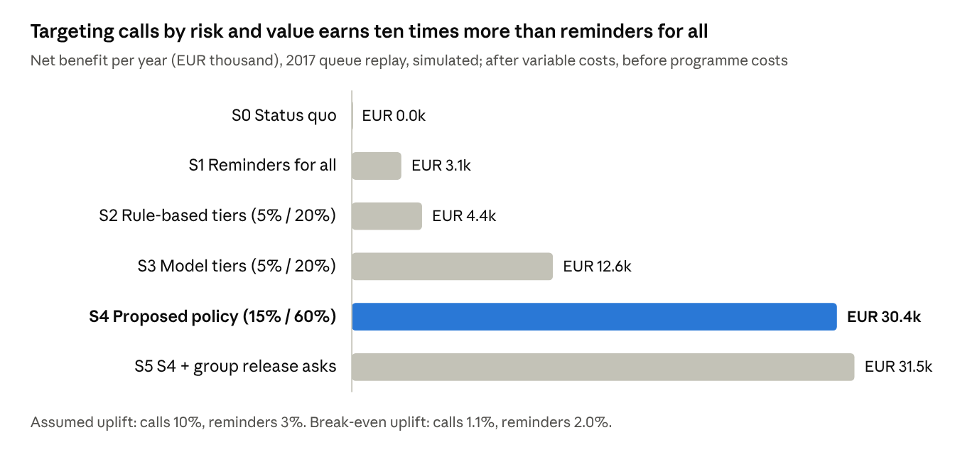

3.3 Evaluation plan
Level | Measure | Status
Model | Precision@20% ≥ 50%, Lift@20% ≥ 1.5, recall ≥ rule, Brier < baseline | Met on 2017 test
Targeting | Cancellation rate and value share in contacted tiers | Call tier 38.3% vs 24.0% queue rate; 44.8% of cancelled value
Business value | Net benefit, ROI, break-even uplift | Positive under assumptions
Causal effect | Stay rate and contribution, treatment vs randomised holdout | Pilot needed
Guest experience | Opt-outs, complaints, backfire | Pilot needed
Monitoring: Lift@20% and predicted vs actual rate monthly, retraining quarterly (AUC fell from 0.80 to 0.71 during 2017). The dashboard's Model monitoring page recomputes them on the bookings that arrived before today.

4. Tools
The prototype links risk scoring, the decision policy and an operational layer for staff, and opens on one fixed working day, Monday 1 May 2017, with the team's history up to yesterday prepared through the same rules; it is built and tested, but contacts no guest and changes no PMS, price or inventory record.
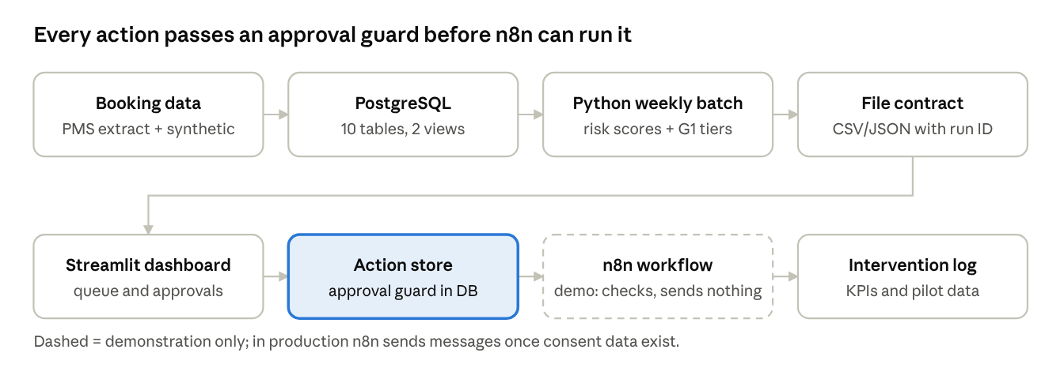
System architecture and workflow
Tool | Role | Why it fits
Python (pandas, scikit-learn, XGBoost) | Weekly scoring, G1 tiers, schedule, scenarios | Reproducible batch runs with run ID and hashes; invisible to managers
CSV/JSON contract | Hands scores, queue and schedule to the dashboard | Human-readable, versioned; can move to an API later
PostgreSQL 16 / SQLite | Hotel data model and shared action store | Constraints and multi-user access; SQLite for a no-setup demo
Streamlit | Staff dashboard: daily overview, risk queue with batch review, action review and approvals, execution and follow-up, capacity planning, performance, model monitoring | Filters and buttons, no coding; needs login for production
n8n | Hands approved actions to a workflow | Visual steps that operations staff can review; scales with workers
2017 outputs. 13,156 risk scores (12,102 individual, 1,054 group); a decision queue routing 1,761 bookings to calls, 5,186 to reminders and 5,116 to standard confirmation; and 20,563 dated actions. Before showing anything, the dashboard checks that model and policy come from the same run, re-derives every tier and rejects any post-outcome field. Outcomes are shown only for bookings that have already arrived (look-back, performance, model monitoring) and never feed a recommendation.
- Controls: Each week's routine plan (calls, reminders, confirmations) is approved by Reservations in a batch before anything is scheduled. Every action is checked for approval, due date, call window, the 20-calls-a-day limit and same-day messaging before n8n receives it. Sensitive actions (price, capacity, deposits) stay pending until a named Revenue Manager approves, and overbooking is refused by the service, n8n and the database.
- Verification: 263 automated tests pass on SQLite (21/10/2026) and 172 on PostgreSQL (20/10/2026); database scripts pass 30/30 load and 19/19 guard checks; the live local n8n workflow accepts approved calls and refuses pending actions.
- Built vs. design: Built: data pipeline, model, decision policy, dashboard, action store and demo n8n workflow. Still a design: login and roles, real message sending, consent data, and pilot treatment/holdout assignment. The dashboard's history up to today is prepared, not observed: guest answers are derived from each booking's real outcome.

5. Expected value, roadmap and risks
The expected value is a simulated, assumption-based estimate; the pilot turns it into a measured result before any scale-up.
Business function | Expected value | How it is measured
Risk prediction | Precision@20% ≥ 50%, Lift@20% ≥ 1.5, recall at least equal to a simple rule (achieved: 58.3%, 1.70) | Time-ordered test vs baseline rules
Prioritisation | Call top 15% by risk × value, remind the next 45%, within 20 calls a day | Cancellation rate and value share in contacted tiers
Customer retention | Lower cancellation in treatment than in a randomised holdout, with no rise in opt-outs or complaints | Stay-rate uplift by assigned arm
Finance | EUR 30.4k a year net; 3-year ROI 173%; payback 6.9 months from roll-out (month 23) | Incremental contribution minus programme cost
Rooms and operations | Group release asks add about EUR 1.1k a year (S5, simulated) | Resale rate, unsold room-nights by date

Implementation Roadmap
- Offline validation (complete). Model and policy tested on a simulation of the 2017 weekly queue.
- Prepare and shadow-score (months 1–5). Integrate the booking feed and train staff; score live bookings weekly for 4–8 weeks without acting, to confirm data are available at booking time.
- Randomised pilot (months 6–17). Assign eligible bookings to treatment or holdout before contact, stratified by tier; measure stay rate, net contribution and CX guardrails.
- Follow-up and evaluation (months 18–22). Four months for pilot bookings to reach their arrival date, then one month to evaluate.
- Scale or redesign (from month 23). Scale only with a positive net effect; retrain quarterly and monitor Lift@20% monthly.
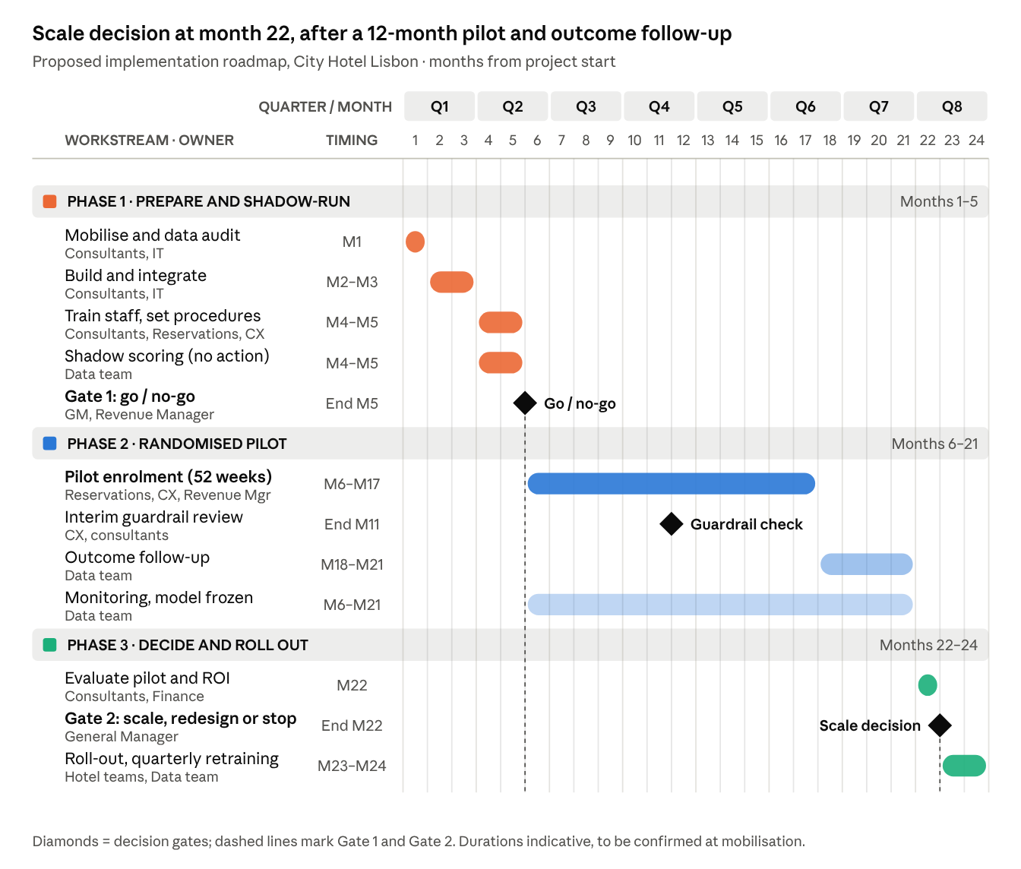
Key risks and mitigations
Risks | Mitigation
Call uplift is unproven and drives the business case (break-even 1.1%) | Randomised pilot with a stop / redesign / scale rule
A one-hotel, one-year pilot detects only about a 5-point effect, above the assumed 3.5 points | Treat the pilot as a go/no-go decision with CX guardrails, or pool across properties
Snapshot data: values are near-arrival, not booking-time | Shadow scoring with time-stamped booking history before go-live
Model drift (AUC 0.80 → 0.71 during 2017) | Monthly monitoring, quarterly retraining
Reminders may trigger cancellations (backfire) | Contact only the top 60%; track post-reminder cancellations by arm
Privacy and fairness | GDPR minimisation, human approval for sensitive actions, country excluded
Decision requested: Approve a 12-month randomised pilot of the S4 policy (one-off cost about EUR 15.6k, EUR 3.4k a year to run), with Reservations, CX and the Revenue Manager as owners.

References
Alkan, T. Y. (2025). A comparative study of machine learning and deep learning approaches for hotel booking cancellation prediction. International Journal of Scientific Research in Engineering & Technology, 5(3), 11–18. https://doi.org/10.59256/ijsreat.20250503002
Antonio, N., de Almeida, A., & Nunes, L. (2017). Predicting hotel booking cancellations to decrease uncertainty and increase revenue. Tourism & Management Studies, 13(2), 25–39. https://doi.org/10.18089/tms.2017.13203
Antonio, N., de Almeida, A., & Nunes, L. (2019). Hotel booking demand datasets. Data in Brief, 22, 41–49. https://doi.org/10.1016/j.dib.2018.11.126
Yoo, M., Singh, A. K., & Loewy, N. (2024). Predicting hotel booking cancelation with machine learning techniques. Journal of Hospitality and Tourism Technology, 15(1), 54–69. https://doi.org/10.1108/JHTT-07-2022-0227

